Alert Traveler Instructions

The app is active when you are connected to wi-fi or cellular service. The app sends safety alerts to your phone according to your GPS location (if you enable it) and alerts based on your itinerary through our software.
- Log on to your account by going to https:\\travel.global.grinnell.edu, click the menu bar in the upper right corner, click Login. Enter your Grinnell email and password. Click on the “Home” icon. Click on “Applicant”. NOTE: This may be done on your phone or computer.
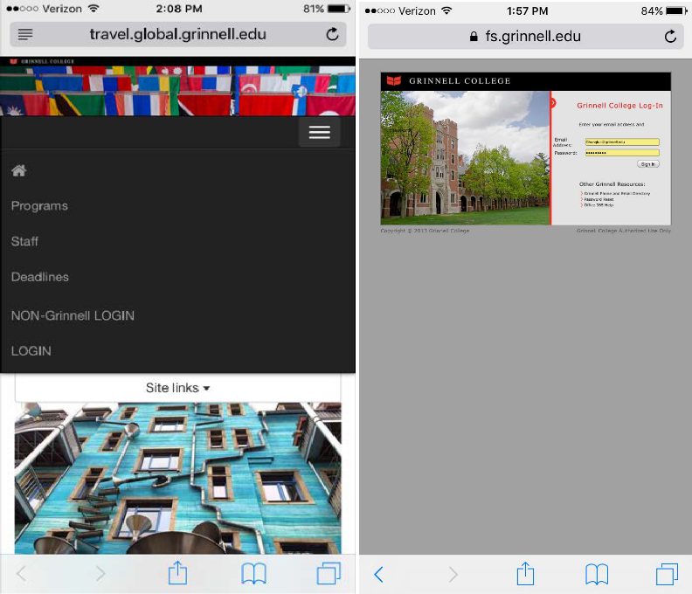
- Use the App store and search for either TerraDotta or AlertTraveler.
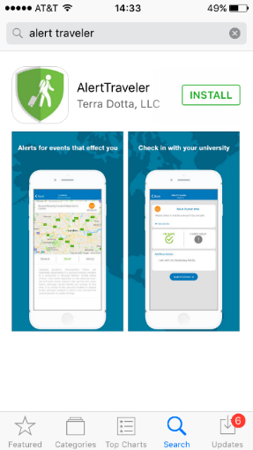

- After the app is open, it will prompt you for a username and password. Return to the homescreen on https:\\travel.global.grinnell.edu. Scroll all the way down until you see the AlertTraveler Registration section with a button at the bottom that says “Generate.” Use your Grinnell email (using all capital letters) and your personalized password created by generate. Copy and paste this information into the app screen and click Login.

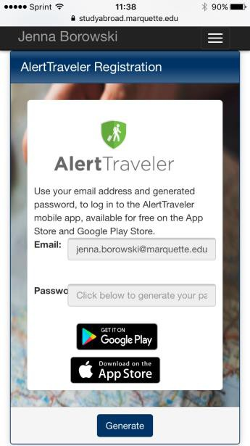
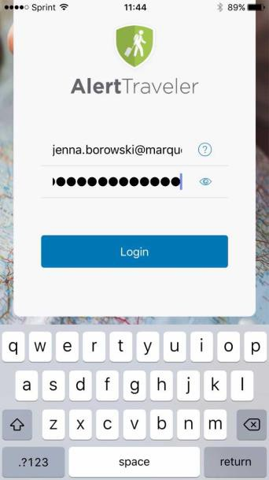
Email here

- Remember your Email must be ALL CAPS. Click on the eye in the password field to see what is being typed.
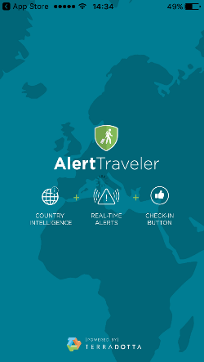

- Explore the various sections of the app to familiarize yourself with the options. You will receive alerts for the country your program is in, as well as the country your GPS locates you in. You can also research other countries by using the top right search button. The menu button in the top left corner will have 5 options.
  - Location Info: This gives you information about your GPS location. Here you can look at the safety alerts, political conditions, security issues, travel logistics, cultural factors, health advisories and other useful information. The contacts button also gives you the emergency numbers for your area.
  - Subscriptions: This shows which countries you are currently receiving notifications for. This will include the country on your itinerary and the country of your GPS location.
  - My Alerts: This section details each safety alert for the countries you have subscribed. Depending on the severity of the alert, it may provide a button for you to “Check in” and verify you are ok.

