Alert Traveler Instructions

The app is active when you are connected to wi-fi or cellular service. The app sends safety alerts to your phone according to your GPS location (if you enable it) as well as alerts based on your itinerary through Terra Dotta (our online application database). The app requires a few steps while it is downloading to successfully install the app.
- Log on to your Terra Dotta account by going to https:\\travel.global.grinnell.edu, clicking the menu bar in the upper right corner, clicking Login, and entering in your Grinnell email and password as shown below. Click on the “Home” icon. Click on “Applicant”. NOTE: This may be done on your phone or computer. These are screen shots from an iPhone.

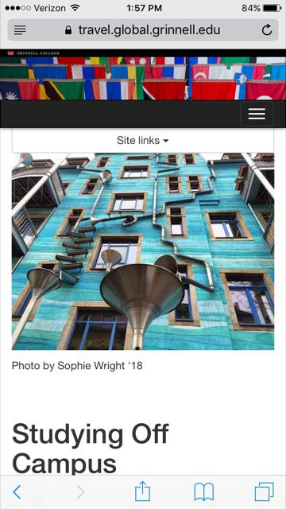
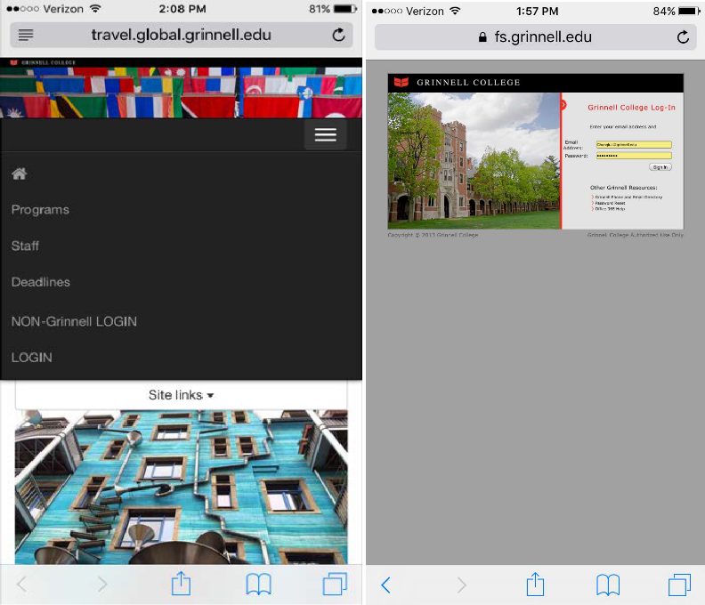
- Downloading the App: through the App store on your phone by searching for either TerraDotta or AlertTraveler. Proceed to download the app to your device and open it.
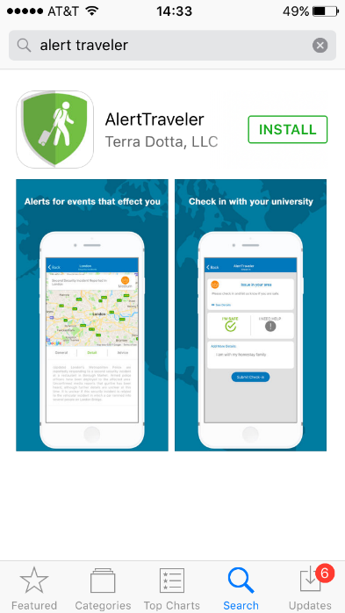

- After the app is open, it will prompt you for a username and password. Return to the homescreen on https:\\travel.global.grinnell.edu. Scroll all the way down until you see the AlertTraveler Registration section with a button at the bottom that says “Generate.” Use your Grinnell email (using all capital letters) for the email section and after pressing generate, your personalized password will appear. Copy and paste this information into the app screen and click Login.

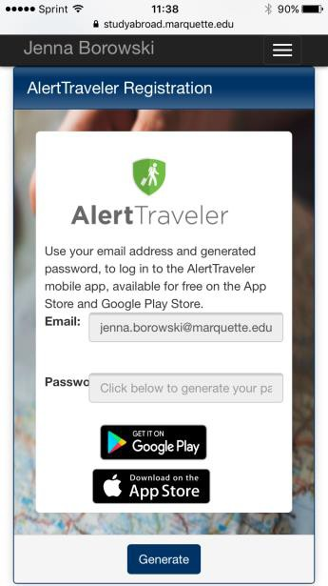
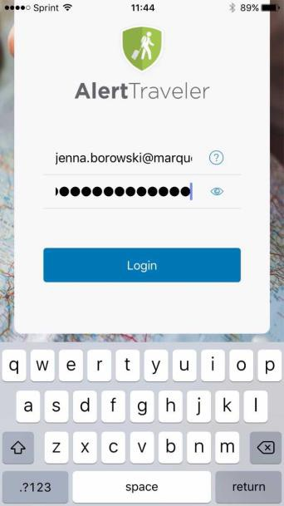
Email here
golden.eagle@marquette.edu
- NOTE: Email must be ALL CAPS. Click on the eye in the password field to see what is being typed.
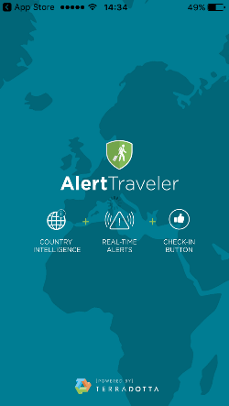

- Now that you have installed the app, you will receive safety alerts on your mobile device. Explore the various sections of the app to familiarize yourself with the options. You will receive alerts for the country your program is in, as well as the country your GPS locates you in. In the example below, the person is in the United States, but also receives safety alerts from Israel because their Terra Dotta itinerary indicates they are in Israel. You can also research other countries by using the top right search button. The menu button in the top left corner will have 5 options.
  - Location Info: This gives you information about your GPS location. Here you can look at the safety alerts, political conditions, security issues, travel logistics, cultural factors, health advisories and other useful information. The contacts button also gives you the emergency numbers for the area you are in.
  - Subscriptions: This shows which countries you are currently receiving notifications for. This will include the country on your Terra Dotta itinerary and the country of your GPS location.
  - My Alerts: This section details each safety alert in the countries you have subscribed to. Depending on the severity of the alert, it also provides a button for you to “Check in” and verify you are alright.

- Allow AlertTraveler to send you notifications, if it asks. You may wish to select to use the app only when wi-fi is 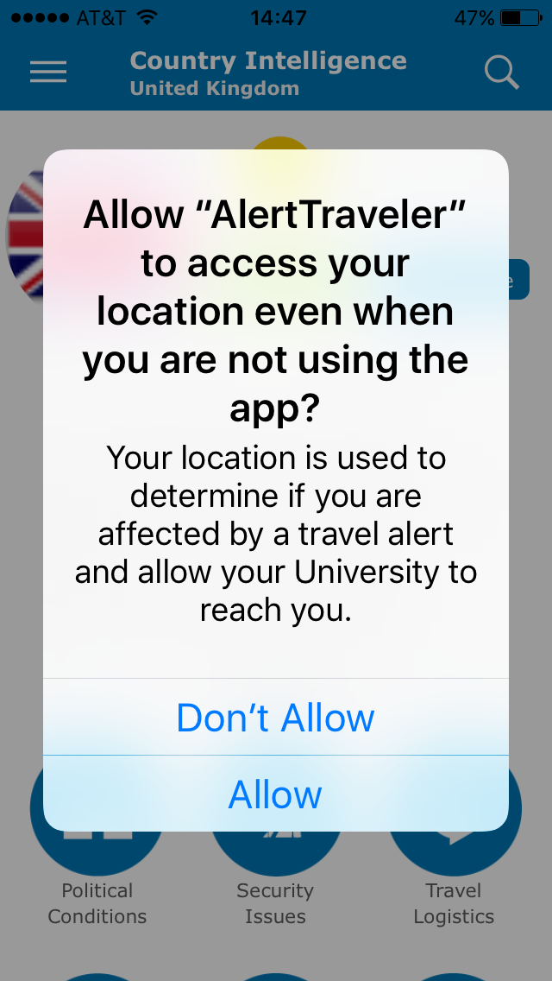available by changing your settings. 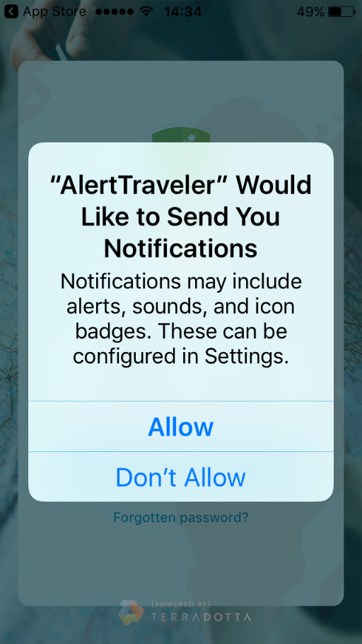

Navigation Menu
A hamburger menu (≡) on the top left of the screen serves as the navigation menu throughout the app. Menu options include Location Info, Subscriptions, My Alerts, Emergency Contact, Profile, and Help. Each of these options is described below.
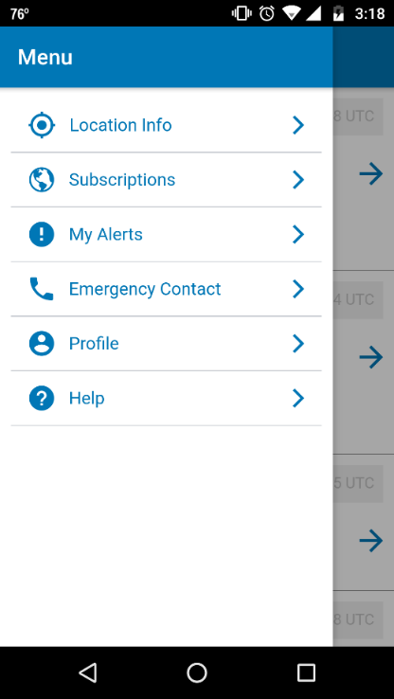

Location Info
Upon selecting Location Info, the user will land on a Country Intelligence page for the country the user is currently in, based on the GPS-reported location of their device.
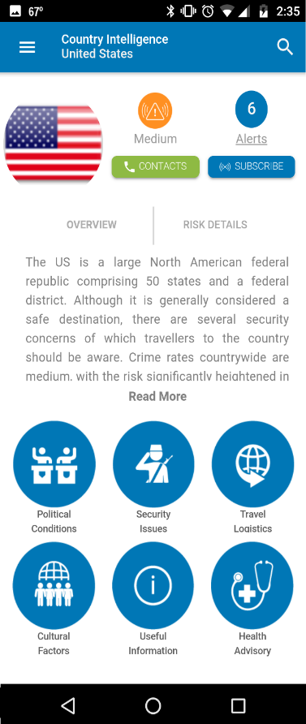
The Location Info page displays the flag of the country, the current risk rating for the country, and the number of active alerts for the country across the top. There are two tabs below: Overview and Risk Details. The Overview tab provides a description of the safety and security profile of the country. Tapping "Read More" expands this section. The Risk Details tab provides a dashboard-like view of six factors that contribute to the country's overall risk rating. Tapping "Show full assessment" expands this section to fill in more details.
- Tapping the Alerts icon will take a user to a page that displays all active alerts for that country sorted by the the time they were issued (see "My Alerts" below for more information about alerts).
- ​The Contacts button at the top of the screen takes the user to a page that displays Emergency Contact information for the country displayed, including icons programmed to call police, fire, ambulance, and emergency numbers. Tapping any of the icons displays the appropriate emergency service phone number for that location at the bottom of the screen. Tapping that number causes the mobile phone to call that number. This page also displays the Institution Emergency Contact phone number and information configured in AlertTraveler > Settings on the administrative side in TDS. Finally, links to information for select diplomatic embassies are provided at the bottom of this page. See also: "Emergency Contact" below.
- The Subscribe button on the Country Intelligence page allows a user to create an opt-in subscription to alerts for that country. See information on configuring subscriptions below.
- The bottom of the Country Intelligence page displays icons that allow the user to tap and access further information about the political conditions, security issues, travel logistics, cultural factors, health advisories, and other security and practical travel information about the given location.
- The magnifying glass at the top of this page allows a user to search for other Countries, Cities, and Territories, and view the Country Intelligence pages for those locations.

Subscriptions
The Subscriptions page allows a user to view and configure the subscriptions that determine the notifications and alerts they receive through AlertTraveler. This section lists the different types of subscriptions and how they are managed.
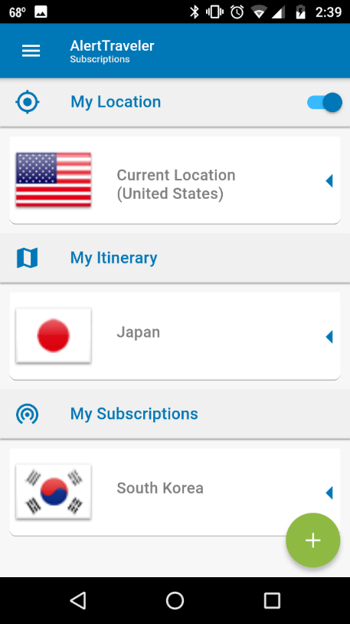
The top of the page displays the country of the user’s current location based on GPS. Users will automatically be subscribed to alerts for this location unless this setting is disabled by tapping the slider in the “My Location” heading.
The subscriptions under the “My Itinerary” panel are based on the user’s travel itinerary as stored in the Terra Dotta software (TDS) site, and will include any locations included in any TDS itinerary. Current and future itineraries will be displayed, but alerts will only be received for currently active itineraries.
The “My Subscriptions” section will display any opt-in subscriptions the user has created.
A user can create an opt-in subscription by tapping the green “plus" (+) icon in the bottom right corner of the screen.
- The user is presented with a search screen where they can type the location to which they wish to subscribe. As the user types, suggested locations will populate on the screen, accompanied by a “Subscribe” button. Tapping the “Subscribe” button will bring the user to a screen where they can configure their subscription settings (refer to “Subscription Settings” below).
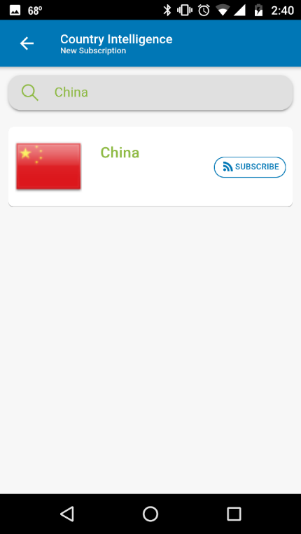
A user can unsubscribe from a subscription under “My Subscriptions” by tapping the arrow to the right side of the subscription box, tapping “Unsubscribe," and then confirming.
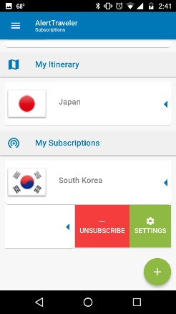

Subscription Settings
The settings for any subscription on the Subscriptions page can be accessed by tapping the arrow on the right side of the subscription box and tapping “Settings."
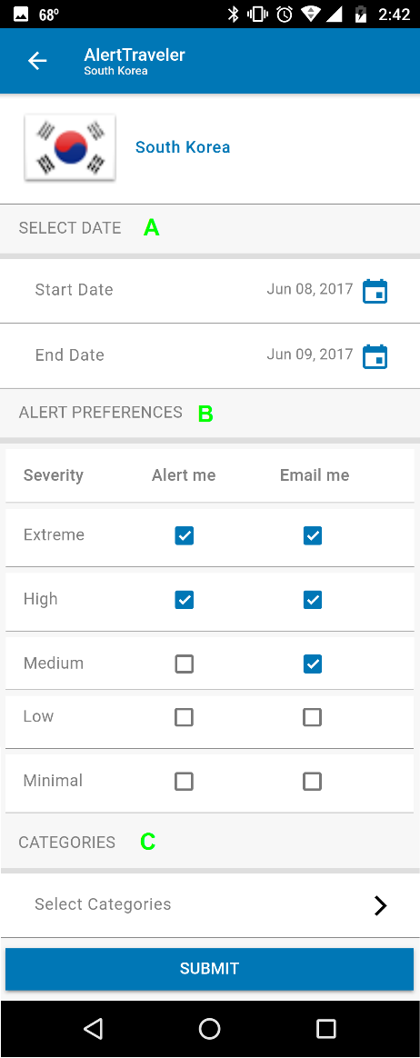
The following settings are available on the subscription settings page:
- A. Start and End Date - the user can set a start and end date for their subscription to alerts for this location. Note: GPS-location-based subscriptions do not have start and end dates. Itinerary-based subscriptions show start and end dates, but they cannot be edited in the app. In order to edit itinerary-based subscriptions, you need to edit the appropriate itinerary in the Terra Dotta software.
- B. Alert Preferences - the user can decide whether to be alerted via mobile-device notification and/or email for each level of alert severity by checking the appropriate boxes. Note: preferences for email alerts are overridden by the Threshold set by Administrators in TDS (AlertTraveler > Settings) for GPS and itinerary-based subscriptions.
- C. Categories - tapping "Select Categories" opens an interface in which the user can disable alerts for specific categories by selecting/deselecting the appropriate categories and tapping “OK.”
Changes on this page are saved by tapping “Submit” at the bottom of the screen.

My Alerts
The My Alerts page displays any alerts impacting the user, based on their GPS, Itinerary, and opt-in subscriptions (See “Subscriptions” above). Newer alerts will appear on the top. Alerts will be displayed with their incident type, severity level, the alert headline, and the time the alert was issued (in UTC). If a check-in request has been issued, a “Check-in” button will also be displayed with the associated alert (see “Check-in Requests” below). 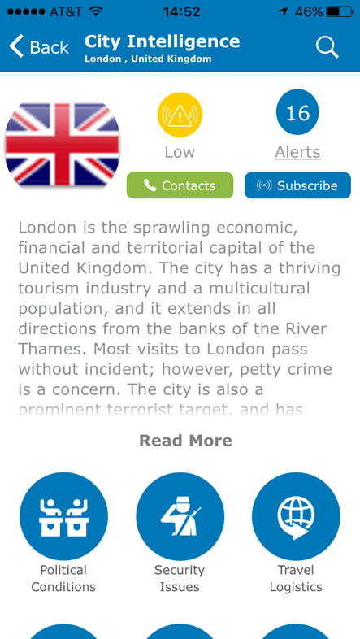
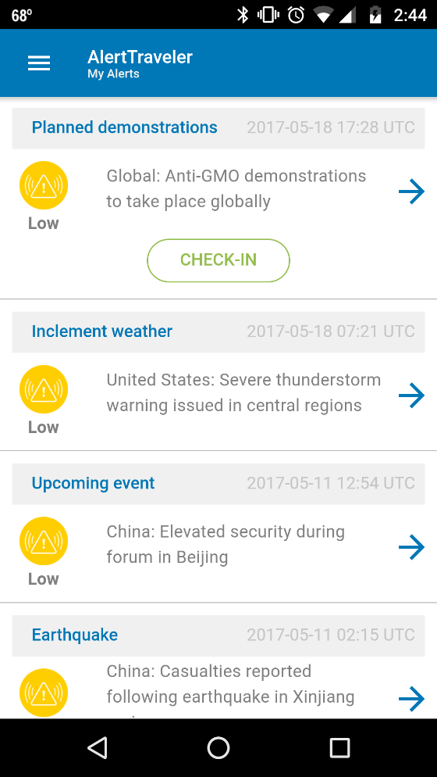
Tapping an alert takes the user to the full details of the alert. A zoomable map of the impacted area, the severity level, and the alert headline are displayed, as well as four tabs: General, Detail, Advice, and Analysis. Note: Some alerts will not have all four tabs.
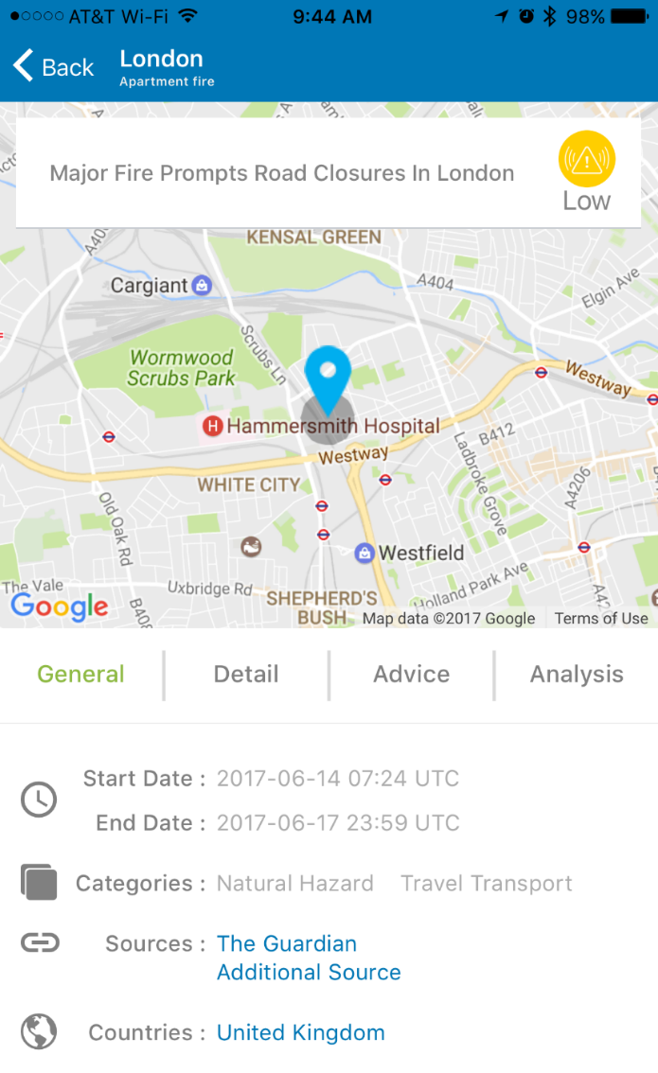
- The General tab displays the start and end date and time of the alert, the alert category (e.g. Natural Hazard, Travel Transport, etc.), links to sources of information about the incident, and a link to the Country Intelligence pages of impacted countries.
- The Detail tab provides a detailed synopsis of the incident for which the alert was issued.
- The Advice tab provides advice for impacted travelers.
- The Analysis tab provides a broader view of the incident and insight into potential for further disruptions.

Emergency Contact
The Emergency Contact page displays emergency contact information for the traveler’s current location based on GPS. Across the top of the page are police, fire, ambulance, and emergency icons. Tapping any of the icons displays the appropriate emergency service phone number for that location at the bottom of the screen. Tapping that number causes the mobile phone to call that number. This page also displays the InstitutionEmergency Contact phone number and information configured in AlertTraveler > Settings on the administrative side in TDS. Finally, links to information for select diplomatic embassies are provided at the bottom of this page.
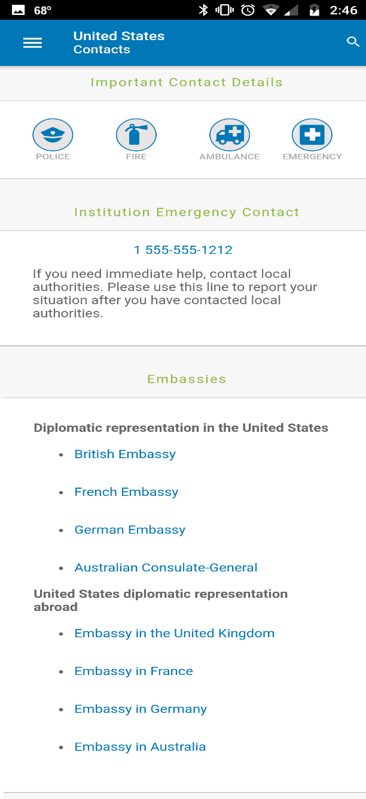

Profile
The Profile page displays the user's contact information and allows them to set or change the phone number associated with their AlertTraveler profile. This is the number to which SMS messages will be delivered when initiated by an administrator. The user is also able to set their alert preferences for the institution-created alerts from this page. This functionality is the same as for regular subscription alerts configured through the Subscriptions page.
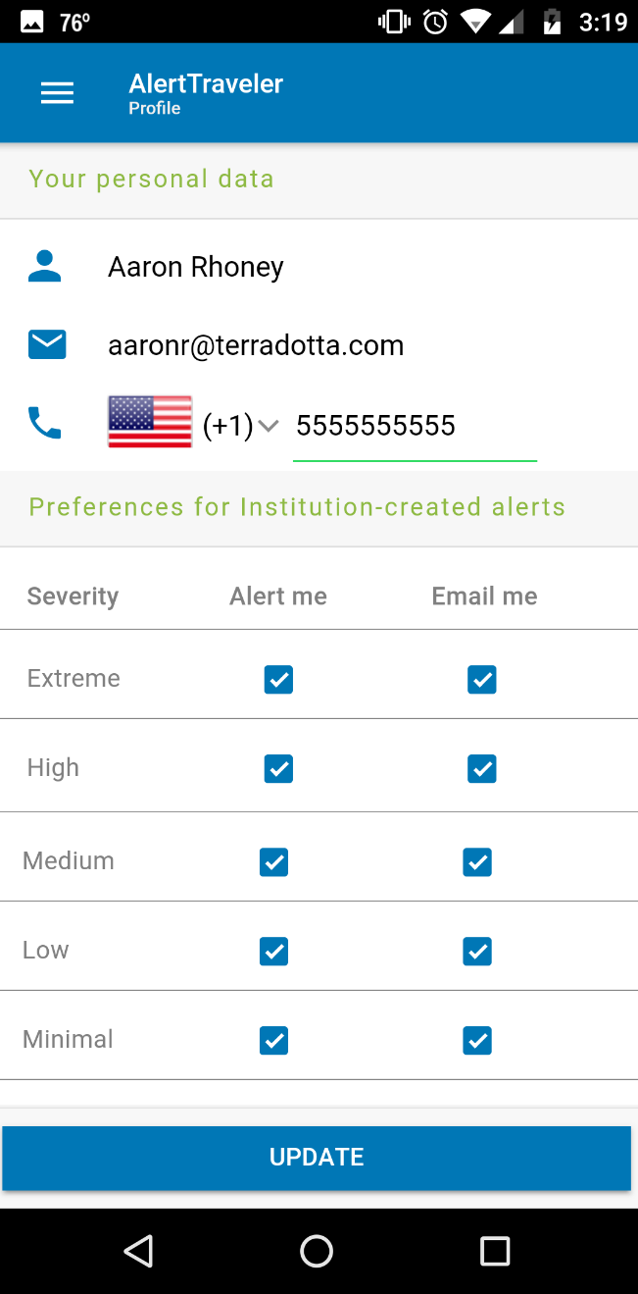

Help
The Help page opens the device’s default web browser and directs travelers to an AlertTraveler FAQ. There is a link at the bottom of the FAQ to a more in-depth online user guide.
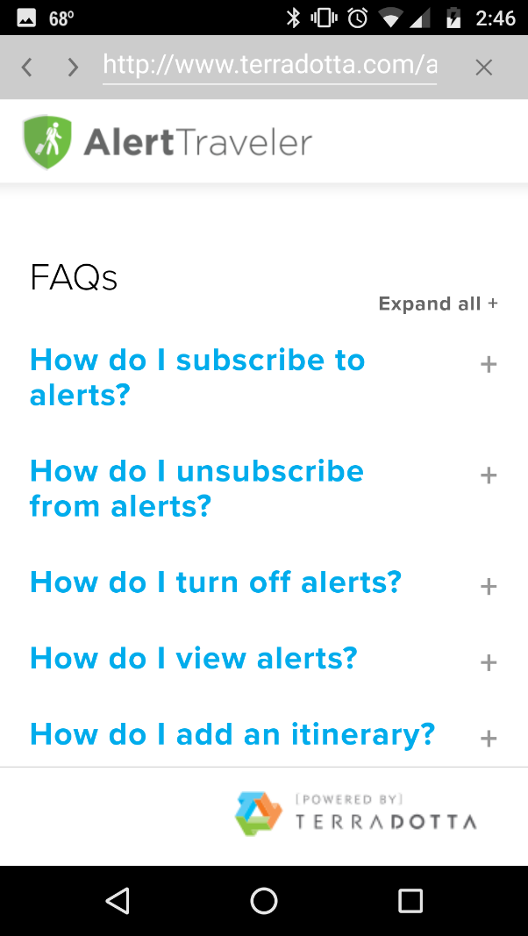
Check-in Requests
When a check-in request is issued for an alert that impacts a traveler, a notification will be pushed to the traveler's device if push notifications are allowed for the AlertTraveler app. Notification preference settings within the app (See "Subscriptions" above) do not affect check-in request notifications. Travelers will also receive the check-in request notification by email. If the traveler taps on the Check-in notification on their device's home or lock screen, the app will open directly to the check-in request. Otherwise, if they open the app after a check-in request has been issued, the user can navigate to My Alerts where the check-in button will appear within the corresponding alert. The check-in button will remain with the alert until the traveler checks in.
After opening the check-in page, the user will see the headline and severity level for the alert and the message provided by the university administrator when the request was generated. Tapping the “See Details” link, will allow them to see the full details page for the alert.
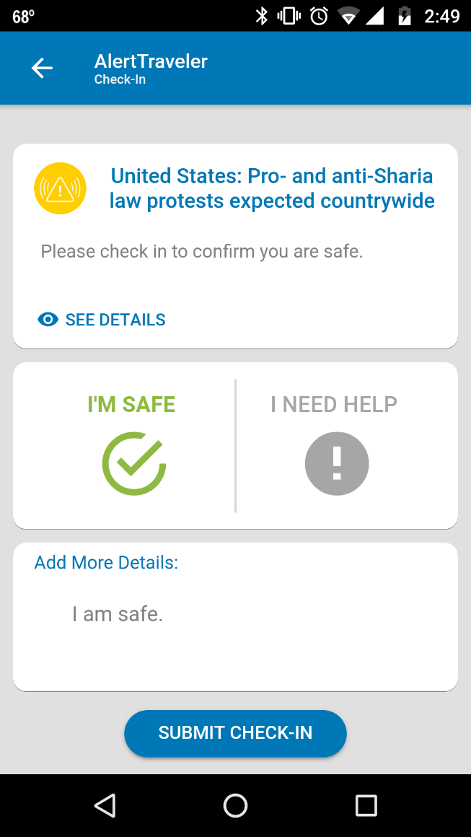
Two buttons are provided for the user to report their status: “I’m Safe” and “I Need Help.” A field is also provided so the user can provide further details about their status. Note: Travelers should contact local emergency services if immediate help is needed.

After the traveler checks the “Submit Check-In” button, TDS administrators will be able to see the updated status of the traveler and the notes they provided by navigating to AlertTraveler > Impacted Travelers within TDS. The traveler will see the status they submitted within the associated alert on their Alerts page.

